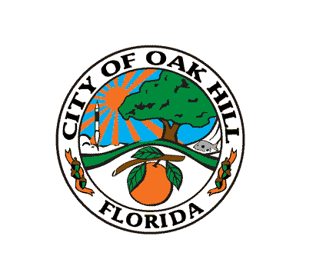
CITY OF OAK HILL

ECONOMIC DEVELOPMENT BOARD

City Hall Chambers
234 South US Highway 1
Thursday
April 16, 2018
6:00 PM
Agenda
Call to Order

Roll Call

Presentations – Discussion of Community Redevelopment Area and other opportunities – Tony Otte, NSB Economic Development Director

Old Business

1. DEO Economic Development plan Grant – Deliverable #1
2. Approval of the following minutes – August 21, 2017, October 16, 2017, November 20, 2017 and January 29, 2018

New Business

1. Public meeting for S.W.O.T. Analysis

Economic Development Director Comments

Board Member Comments

Public Participation

Adjournment

Note: Pursuant to Florida Statute 166.041 (3) (A), if an individual decides to appeal any decision made with respect to any matter considered at a meeting or hearing, that individual will need a record of proceedings and will need to ensure that a verbatim record of the proceedings is made.

